

Spring 2026

Name: Adil Khan
Roll no: 2610-4011
Degree: BS AI

Task no 1:
#include <iostream>
using namespace std;

class Circle;

class Rectangle {
private:
double area;

public:
Rectangle(double length, double width) {
area = length * width;
}

friend void compareArea(Rectangle, Circle);
};

class Circle {
private:
double area;

public:
Circle(double radius) {
area = 3.14 * radius * radius;
}

friend void compareArea(Rectangle, Circle);
};

void compareArea(Rectangle r, Circle c) {
if (r.area > c.area) {
cout << "Rectangle has larger area." << endl;
}
else if (r.area < c.area) {
cout << "Circle has larger area." << endl;
}
else {
cout << "Both have equal area." << endl;
}
}

int main() {
Rectangle rect(10, 5);
Circle circ(4);

compareArea(rect, circ);

return 0;
}

Output:
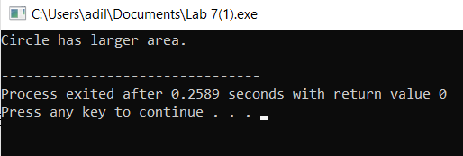

Task no 2:
#include <iostream>
using namespace std;

class Car;

class Engine {
public:
void increaseHorsepower(Car &c);
};

class Car {
private:
int horsepower;

public:
Car(int hp) {
horsepower = hp;
}

void display() {
cout << "Horsepower: " << horsepower << endl;
}

friend class Engine;
};

void Engine::increaseHorsepower(Car &c) {
c.horsepower += 50;
}

int main() {
Car myCar(100);
Engine eng;

cout << "Before increase:" << endl;
myCar.display();

eng.increaseHorsepower(myCar);

cout << "After increase:" << endl;
myCar.display();

return 0;
}

Output:
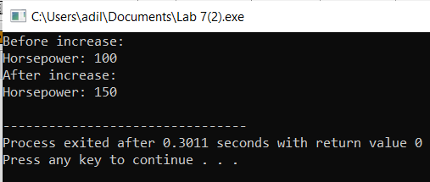

Task no 3:
#include <iostream>
using namespace std;

class Number {
private:
int value;

public:
Number(int v) {
value = v;
}

void display() {
cout << "Value: " << value << endl;
}

friend void increment(Number &n);
};

void increment(Number &n) {
n.value++;
}

int main() {
Number num(10);

cout << "Before increment:" << endl;
num.display();

increment(num);

cout << "After increment:" << endl;
num.display();

return 0;
}

Output:
